ACTIVITIES AND RETREATS FOR 2016

Temple of Light

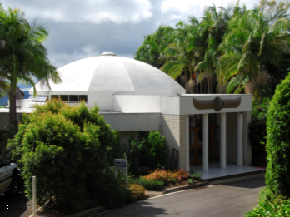

WHITE EAGLE LODGE
PO Box 225 (19 Tesch Road)
MALENY QLD 4552

Tel: 07 5494 4397
Email: info@whiteeaglelodge.org.au
Web: www.whiteeaglelodge.org.au

Temple Activities

Monthly Sunday Service of Worship commencing at 11 a.m. If you would like to stay for lunch, please bring a plate of vegetarian food to share. Contact Healing follows at 1.30 p.m. Service dates are: -

February 7th March 6th April 3rd
May 1st June 5th July 3rd
August 7th September 4th October 2nd
November 6th December 4th
December 17th 4 p.m. Jingle Bell Supper & 6 p.m. Carols by Candlelight

WEEKLY ACTIVITIES: -
Monday to Friday 12 noon World Healing Prayers
Monday 9.30 a.m. Dru Yoga with Clare Russell Please phone or email the Lodge for more
details.
Tuesday 9.30 am Absent Healing Group **
10.30 am Meditation
2 pm Contact Healing available by appointment
Thursday 11.00 am Absent Healing Group

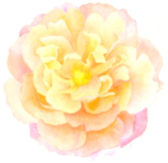
RETREATS FOR 2016

Easter Retreat

MARCH: Arriving Thursday evening 24th March finishing Sunday afternoon 27th March, 2016

Limited spaces available

Did you realise “listen” is an anagram of “silent”?

We are all seeking that still point with us—that centre of peace, that point of light which is an expression of our oneness with our Creator.

In the silence we have the opportunity to really listen—to listen to our hearts, our own intuition, our bodies on every level, our guide, our personal Angel and most importantly to listen to God.

We cannot listen whilst the mind is chattering and the emotions overwrought. This retreat gives us the opportunity through silence to listen.

During this retreat participants are encouraged to maintain silence on Friday, Saturday and Sunday unless you have a specific problem you would like to discuss with the facilitators. Each morning and afternoon sessions will include Cellular Alchemy, gentle exercise program, a short talk and the focus will be on meditation and going within.

Cost: $550 which includes accommodation, all linen, meals and all activities. Members discounted price—$525. Places are limited on this retreat as each participant will have a single room—so be quick to book.

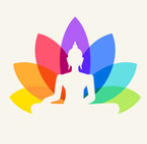
Mindfulness & the Four Noble Truths”

MAY: Arriving Thursday afternoon 19th and departing Tuesday 24th May.

Buddha taught mindfulness as a way of living and right throughout White Eagle’s teachings when we look with new eyes we can see that White Eagle is teaching us to be mindful and to live in mindfulness and kindliness.

This retreat over the Wesak period and the full moon when the Buddha blesses the earth with his golden energy is a particularly powerful time to explore the four noble truths as related by the Buddha and reinforced by the teachings of White Eagle.

During this retreat we will have the opportunity to: -
- Change our life
- Gain a deep sense of peace and clarity
- Look at our life and our suffering in a different way bringing a more positive attitude into our lives.

Cost: $680 which includes accommodation, all linen, meals and all activities. Member discount price - $650

“Be the Light Being you were born to be”

JULY: Arriving Saturday 2nd and departing Friday 8th July, 2016

White Eagle said: - “Every soul living on earth is in a physical body in order to build and create in due time that body of light which the ancient Brotherhoods called the solar body.

The power which commands the Light and creates man’s solar body is the power of love. When the body of light has been created in man/woman, the whole physical body becomes illumined, and thus a purer vehicle for the use of the soul.”

During this Retreat we will have the opportunity to: -
∗ Building the Light into and strengthening our Seed Atom
∗ Develop the solar body through meditation and God-Thought
∗ Create an easier pathway of Light when we finally make our transition into the world of Light - we can do so in a body illumined with Light and Love.

Cost: $850 which includes accommodation, all linen, meals and all activities. Members discounted price—$800

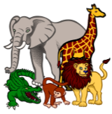
St Francis—Blessing of the Animals

Sunday 2nd October
During the Sunday Service of Worship at 11 a.m.

A short service will be held to bless our beloved animals and to give thanks for their life and the companionship they give to us.

You may like to bring a photo of your pet. For those unable to attend please feel free to send in a photo and your pet will be included in the service.

If you don’t have a pet perhaps you have a special affinity to a particular species in the wild which we can include e.g. dolphins, whales, koalas. Our beautiful Mother Earth and all nature will be also held in the Light of the Star.

**Absent Healing Groups:
The Absent Healing Group meets weekly to project coloured rays to the soul of patients who have asked for help and healing. The Service is very much about giving from one’s heart but as you give so you receive. If you feel you would like to do the healing work and are a member of the Lodge but cannot attend group meetings, Lone Healing is also available where you work on a healing list in your own home. If you would like to be a patient on the healing list you may like to write to the Lodge for more information.

For list of Groups in Australia and New Zealand please phone the Temple on 07-54 944 397 or visit the web site www.whiteeaglelodge.org.au

